Project Plan
Name of Project |  | Future Garden |  | Duration: 6 weeks
Project Subject |  | Science
Other subject areas to be included, if any |  | Geography, Math, Language, Arts
Objective |  | Students are able to design a future school garden which will be suitable for a dry season or hot climate
Project idea  Summary of the issue, challenge, investigation, scenario, or problem |  | Students do some investigations to find out the average rainfall and climate change in the city they live in. Then collaborate together to find information on plantation suitable for dry area. And finally they design and present a garden of the future which do not need too much water and can be home of ecosystem around it.
Driving question |  | How would you design a garden for the future, in which the plants do not need too much water and can be a home for the ecosystem around it.
Content standard to be taught and assessed |  | - Introduction to the case of climate change and its impact  - Do online research on average rainfall and climate, then summarize the result (Math & Geography)  - Discussing on different types of plants and do online research (Science & English)  - Design A Future School Garden (Science, Math, Geography, Arts)  - Prepare and do a presentation of the design (English)
21st century skills to be taught and assessed |  | Communication  Collaboration  Critical thinking/problem solving  Information & Tech literacy
Major Products | Group | Poster  Presentation
Assessment | Formative Assessment (During Project) | - Learning Log  - Practice presentation  - Rubric for communication and collaboration
 | Summative Assessment (End of Project) | - Rubric for presentation  - Peer evaluation
Reflection method to look back on content and process | Group | - Whole class discussion
 | Individual
Timeline of Activities

Details of the activity
- Introduction to the case of climate change and it’s impact

If you walk in the park or look around chances are you’ll see a garden growing. These special patches of paradise are an ecosystem. They are home to bugs, birds, and mammals and the plants they depend on. You might even be lucky enough to find a slimy amphibian or a scaly reptile there. But just like you, plants need water to survive. If the climate is too hot, water evaporates, it turns from liquid into gas - water vapour. If the climate is too cold, water freezes, it turns from liquid into solid – ice. So how will our gardens look as the climate changes? As plant species have evolved they have adapted to the different climate conditions that they grow in.

Our project is designing a garden for the future, in which the plants do not need too much water and can be a home for the ecosystem around it.

- Do online research and summarize the result
Students Search data on the average rainfall and the climate graph in the city they live in.
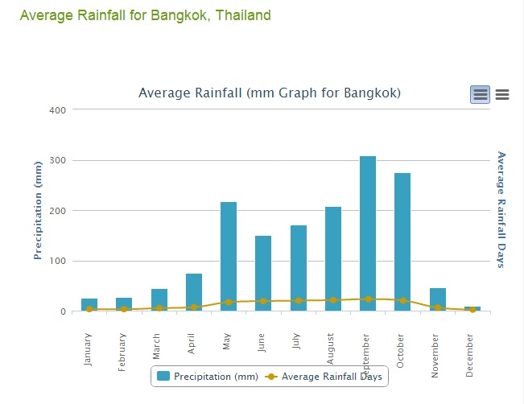
Picture 1. Example of Rainfall Graphic in Bangkok
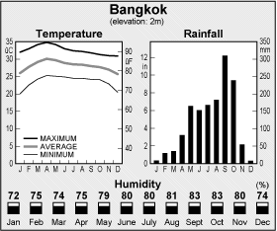
Picture 2. Example of average rainfall and temperature in Bangkok

Students read the data and summarize it based on the following guided questions:
- What is the total rainfall?
- Which is the wettest month?
- Which is the driest month?
- Which months has the most rainfall
- What is the maximum and minimum temperature of the year?
- What is the temperature range (the difference between the warmest and the coolest month)?
- Post the result of the research in Edmodo
Students summarize the result of their online research and post the summary in Edmodo.

- Discussing on different types of plants and do online research
Water is essential for plants to grow. The soil acts like a sponge holding onto the water and letting the excess drain away. When it doesn’t rain for a while the top layer of soil will dry as the water evaporates. Sometimes if you dig down just a few centimetres you can find moist soil.
The amount of water needed to make the soil moist again is called the soil moisture deficit. Some plants can survive a larger soil moisture deficit than others. Plants that can cope with a higher soil moisture deficit will survive best if there isn’t rain for a while.
Search information on based on the following questions. You need to consider different kinds of plants such as shrubs, vegetables, fruits, etc
- Which plants need the most watering?
- Which plants need the least watering?
- Does the height of the plant make a difference?
- Post the result of the online searching in edmodo
Students post the picture and the description of different plants in Edmodo

- Design A School Garden for the future
Students work together in their group to design a school garden for the future. The design will help the garden to grow even if the climate gets drier.

Students need to decide
- How big is the garden?
- Who the garden will be used by (consider the wildlife/animal in the garden)
- What kinds of plants will be put in the garden and where to put it
- Are there any other things need to be put in the garden (decoration)
- What is the cost of creating the garden

- Prepare a presentation of the design
Some points to consider in preparing the presentation
- Why a new type of garden is necessary – What is happening to our climate?
- How you designed your garden?
- What you want it to be like
- How you want it to be managed

